**Weekly Work Plan and Experimental Report**

**(2023-11-26 to 2023-12-12)**

|  |
| --- |
| **Research work plan (previous week)** |
| 1. Will repeat the same experiment this week to reconfirm the EIS results of symmetric cell with PBNC material. The previous work shows some variation in results from same composition samples. So with little modification and ensure the constant time while conducting EIS test of each sample, I have do this experiment again. By doing this, we will get the final composition of PBNC for further analysis. 2. Read literature about the infiltration methods and materials reported by other groups and look for more candidates 3. Will Complete the figures of a review paper on Li-S batteries 4. Read literature about the preparation of full cell methods and skills for prepare full cell |

|  |
| --- |
| **Achieved Targets as per the plan of the previous week** |
| 1. Will repeat the same experiment this week to reconfirm the EIS results of symmetric cell with PBNC material. The previous work shows some variation in results from same composition samples. So with little modification and ensure the constant time while conducting EIS test of each sample, I have do this experiment again. By doing this, we will get the final composition of PBNC for further analysis. **Completed** 2. Read literature about the infiltration methods and materials reported by other groups and look for more candidates.**Completed** 3. Will Complete the figures of a review paper on Li-S batteries. **Completed** 4. Read literature about the preparation of full cell methods and skills for prepare full cell. **Completed** |

|  |
| --- |
| **Research work plan (This week)** |
| 1. Will replace the barium with another material as the results are not better than PNC composition, or to change the PBNC preparation methodology for improving the performance. 2. Will prepare single cell through tape casting or spin-coating/dry-pressing method 3. Will discuss about the review paper on fabrication of PCECs through lithography techniques 4. Will read literature about some new technique to improve the air-electrode performance |

**Experimental Results of Research Plan Submitted Last Week**

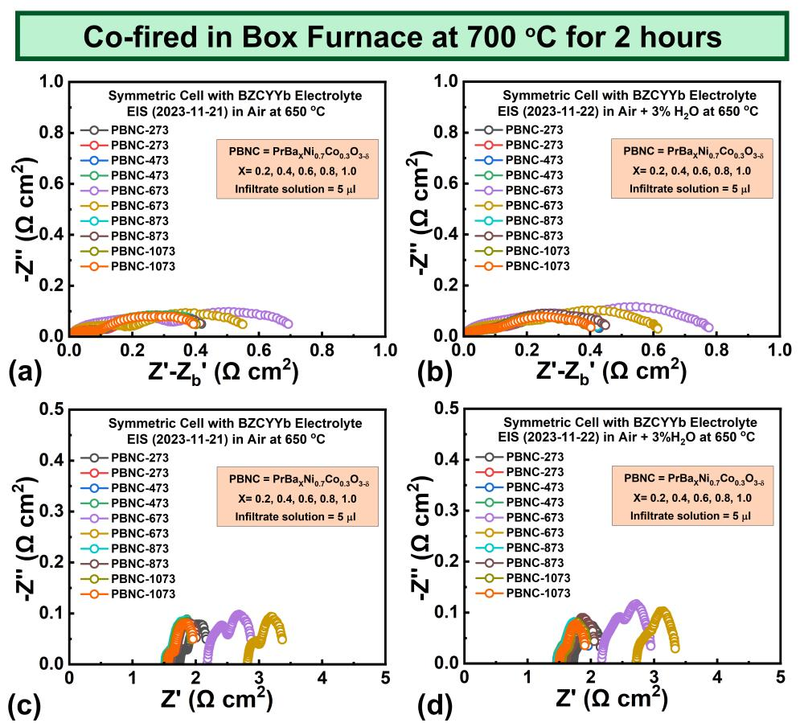

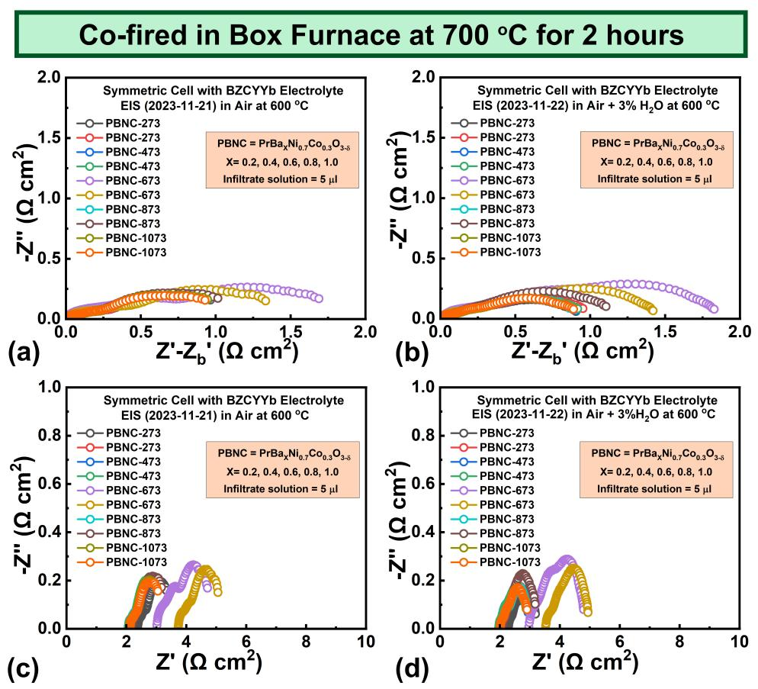

Dr. Muhammad Waqas

Post Doc Researcher

UESTCYDRi